Toast message for late loading web pages

1. Add the code in to **<head><style></style></head>** section

#snackbar {  
 visibility: hidden;  
 min-width: 250px;  
 margin-left: -125px;  
 background-color: #333;  
 color: #fff;  
 text-align: center;  
 border-radius: 2px;  
 padding: 16px;  
 position: fixed;  
 z-index: 1;  
 left: 50%;  
 bottom: 50%;  
 font-size: 17px;  
}  
  
#snackbar.show {  
 visibility: visible;  
 -webkit-animation: fadein 0.5s, fadeout 0.5s 2.5s;  
 animation: fadein 0.5s, fadeout 0.5s 2.5s;  
}  
  
@-webkit-keyframes fadein {  
 from {bottom: 0; opacity: 0;}  
 to {bottom: 30px; opacity: 1;}  
}  
  
@keyframes fadein {  
 from {bottom: 0; opacity: 0;}  
 to {bottom: 50%; opacity: 1;}  
}  
  
@-webkit-keyframes fadeout {  
 from {bottom: 50%; opacity: 1;}  
 to {bottom: 0; opacity: 0;}  
}  
  
@keyframes fadeout {  
 from {bottom: 50%; opacity: 1;}  
 to {bottom: 0; opacity: 0;}  
}

1. Add the script above the full screen, this code is to use css for message box
2. <script>  
    **function** myFunction() {  
    **var** x = document.getElementById("snackbar");  
    x.className = "show";  
    setTimeout(**function**(){ x.className = x.className.replace("show", ""); }, 1000);  
    }  
   </script>

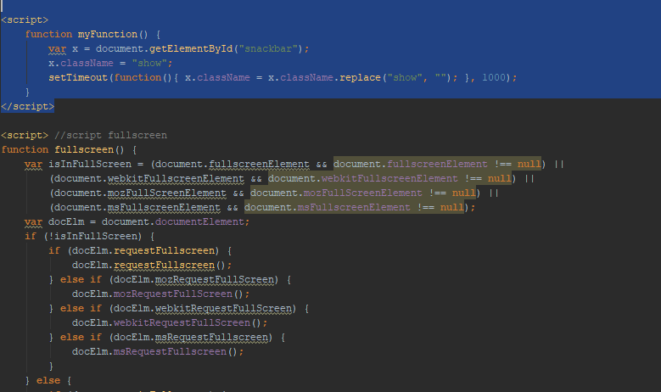

1. Add the div in to class section

<div id="snackbar">Model is loading, Please wait....</div>

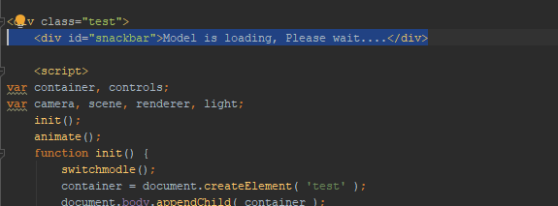

1. Add onload to body tag

